Card Game New Concept

Board Layout
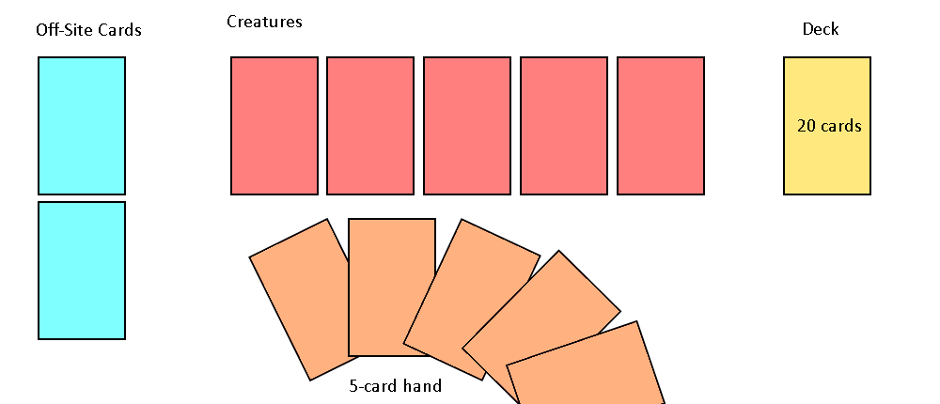

Basic Gameplay
The main currency of this game are “tokens”. There is no limit to how many tokens a player can have, and no restrictions on how many they can use per turn. There are a few ways to gain tokens:
- 1 is automatically given at the start of each turn
- When an opponent’s creature is slain, the player receives tokens equal to the creature’s cost. You do not receive tokens from destroying structures.
- Through special conditions on cards
Every turn, the player must draw a card, and can only have 5 cards in their hand at a time. When discarding a card from the hand, the card goes to the bottom of the deck unless stated otherwise. When a creature or off-site card is destroyed, they are also sent to the bottom of the deck in the order they are destroyed. This system makes the deck an endless cycle. A player has no restrictions on what order they chose to do actions; however, they must draw a card first. For example, the player can choose to attack with a creature, then play 2 cards, then attack with the rest of their creatures. The player can keep acting until they declare the end of their turn. When a player is damaged, they lose 1 life from a total of 10, regardless of the creature’s damage. Off-site cards, unless stated otherwise cannot deal damage to a player. The game continues until there is one player remaining.

Deck Building
Decks contain 20 cards, with a limit of 1 card of the same name per deck. There is no restriction on how may of one type of card can be put in a deck. For example, a deck could have 20 creatures if so desired.

Creatures
Creatures are laid out in a 5x1 grid. When a creature attacks, they can by default attack an adjacent tile with a creature, or the player/off-site cards if the space directly in front is free. When damaging an off-site card, they must damage the first-most card. Every turn, a creature can choose to either attack or move. When moving, the creature can either move to an empty adjacent space, or swap with an adjacent creature. Creatures cannot attack the first turn they are summoned but can still move. Creatures do not passively regain health. When a creature dies, they are moved to the bottom of the deck.

Off-site cards
There are 2 slots for off-site cards. When an off-site card is played, it is forced to go to the back-most slot. These 2 slots have specific identities because of this. Typically, the first card played is supposed to be the card kept alive whereas the second card is intended to protect the first card. If an off-site card has an attack value, they can only attack creatures, but can attack any tile.

Spell cards
Spells are special cards that trigger an effect when used. For example, a fireball that deals 3 damage to a creature. Spells by default can only be used on the player’s turn, however, spells commonly have the instant keyword which allows them to be used at any point in the game. Spells are discarded to the bottom of the deck in the order they are used. Unless stated otherwise, spells can be used on any creature or off-site card.

Effect Cards
Effect cards are special types of cards that are attached to creatures or off-site cards. Effect cards give special effects to the equipped card, like +2 damage. When the card with the equipped effect is discarded, the effect card is exiled instead of being discarded, and cannot be used again for the rest of the game, unless stated otherwise.

Keywords
Jumpy – Creature can move to any empty space on the board
Flying – Creature can attack opponent if the front-facing creature is not-flying
Wide – Creature can attack any creature on the opponent’s board
Swift – Creature can immediately attack
Agile – Creature can move and attack
Instant – Card can be played after any action an opponent takes
Titan – Creature can ignore any creature in front of them when attacking

